**1.What are the two values of the Boolean data type? How do you write them?**

Ans) two values of Boolean datatypes are true and false. In python we write them as True , False

**2. What are the three different types of Boolean operators?**

Ans) and, or, and not are the three different types of Boolean operators

**3. Make a list of each Boolean operator's truth tables (i.e. every possible combination of Boolean values for the operator and what it evaluate ).**

Ans)

**And** truth table

|  |  |  |
| --- | --- | --- |
| A | B | A and B |
| True | True | True |
| True | False | False |
| False | True | False |
| False | False | False |

**or** truth table

|  |  |  |
| --- | --- | --- |
| A | B | A or B |
| True | True | True |
| True | False | True |
| False | True | True |
| False | False | False |

not truth table

|  |  |
| --- | --- |
| A | not(a) |
| True | False |
| False | True |

**4. What are the values of the following expressions?**

**(5 > 4) and (3 == 5)**

Ans) False

**not (5 > 4)**

Ans) False

**(5 > 4) or (3 == 5)**

Ans) True

**not ((5 > 4) or (3 == 5))**

**Ans)** False

**(True and True) and (True == False)**

**Ans)** False

**(not False) or (not True)**

Ans) True

**5. What are the six comparison operators?**

**Ans)**

* Less than ( < )
* Less than or equal to ( <= )
* Greater than ( > )
* Greater than or equal to ( >= )
* Equal to ( == )
* Not equal to ( != )

**6. How do you tell the difference between the equal to and assignment operators?Describe a condition and when you would use one.**

**Ans)** Equal to operation symbol is == and assignment operation symbol is =

Equal to operation is used to check whether values of two variables are equal or not , if they are equal it returns True or else it returns False where as assignment operator is used to provide a value to a variable

**Example:**

a=5

b=6

print(a==b)

**output:**

False

**7. Identify the three blocks in this code:**

**spam = 0**

**if spam == 10:**

**print('eggs')**

**if spam > 5:**

**print('bacon')**

**else:**

**print('ham')**

**print('spam')**

**print('spam')**

**Ans)**

**First block**

if spam == 10:

print('eggs')

**Second block**

if spam > 5:

print('bacon')

**Third block**

else:

print('ham')

print('spam')

print('spam')

**8. Write code that prints Hello if 1 is stored in spam, prints Howdy if 2 is stored in spam, and prints Greetings! if anything else is stored in spam.**

**Ans)**

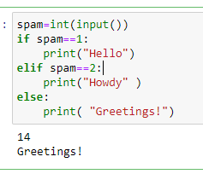

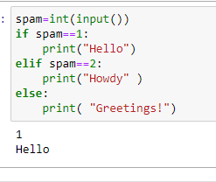

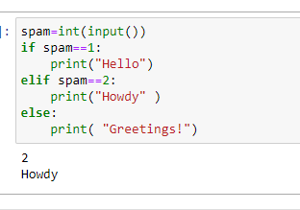

**9.If your programme is stuck in an endless loop, what keys you’ll press?**

**Ans)** we will click on the stop or interrupt the kernel button

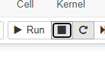

**10. How can you tell the difference between break and continue?**

**Ans)** Break will stop or terminate the execution of the loop , continue will the skip the current iteration of the loop

**11. In a for loop, what is the difference between range(10), range(0, 10), and range(0, 10, 1)?**

**Ans)** The output of above three is same

Syntax of range is range(start, stop, step)

Start -included

Stop-excluded

In range(10) the loop runs from 0 to 9 as start default value is 0, stops at stop-1(i.e 10-1=9) and step default value is 1

In range(0,10) the loop runs from 0 to 9 as start =0 mentioned and even though stop=10 as it is excluded so loop stops at stop-1(i.e 10-1=9) step default value also 1

in range(0,10,1) the loop runs from 0 to 9 because start=0 stop=10-1=9 and step=1

**12. Write a short program that prints the numbers 1 to 10 using a for loop. Then write an equivalent program that prints the numbers 1 to 10 using a while loop.**

**Ans) using for loop**

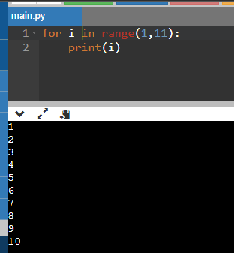

**Using while loop**

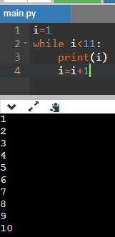

**13. If you had a function named bacon() inside a module named spam, how would you call it after importing spam?**

**Ans)** This function can be called with spam.bacon().